
SUMMER PRACTICE REPORT
SUBMITTED TO THE
DEPARTMENT OF MATERIALS SCIENCE AND ENGINEERING
İZMİR INSTITUTE OF TECHNOLOGY

FOR THE

COURSE: MSE 300 SUMMER PRACTICE 1

COMPLETED AT

SUBMITTED BY:

Summer, 2023

Table of Contents

1. DESCRIPTION OF THE COMPANY 4
1.1. Company Name 4
1.2. Location 4
1.3. Numbers and Duties of Engineers Employed 4
1.4. Main Area of Operation 4
1.5. Brief History of the Company 4
1.6. Organizational Structure of the Company 5
2. INTRODUCTION 6
3. REPORT 7
3.1. Anode Casting 7
3.2. Copper Electrolytic Refining 8
3.3. Continuous Casting 9
3.4. Wire Drawing 11
3.4.1. Single Wire Drawing 11
3.4.2. Multiple Wire Drawing 12
3.4.3. Wire Bunching 13
3.5 Copper Wire Plating 15
3.5.1. Nickel Plating 15
3.5.2. Tin Plating 16
3.6. OFC and Copper Alloys Facility 17
3.6.1. CONFORM 18
3.6.2. Shaving 19
3.7. Ribbon Production Line 21
3.8. Sample Preparation 23
3.8.1. Mounting 23
3.8.2. Grinding 23
3.8.3. Polishing 24
3.8.4. Etching 24
3.9. XDV-μ SPECTROMETER 25
4. CONCLUSION 27
5. REFERENCES 28

List of Figures

Figure 3. Anode Casting [1] 8
Figure 4. Copper Electrolytic Plant [11] 9
Figure 5. Continuous Casting Facility [5] 10
12
Figure 6. Copper Wire in Basket [7] 12
Figure 7. Multiple Wire Drawing Machine (left side), Multiple Wire (right side) [7] 13
Figure 8. Wire Bunching Machine [18] 14
Figure 9. Nickel Plating Line [8] 15
Figure 10. Tin Plating Line Pictures [13] 16
Figure 11. Upward Casting and Coiling [15] 18
Figure 12. CONFORM schematic representation (left side), CONFORM machine (right side) [2] 19
Figure 13. Wire Shaving Machine [9] 20
Figure 14. Ribbon Line (left side), Ribbon Spool (right side) [14] 22
Figure 15. XDV-µ X-RAY device [19] 25
Figure 16. An image from the device. 26

1. DESCRIPTION OF THE COMPANY

1.1. Company Name

1.2. Location

1.3. Numbers and Duties of Engineers Employed

1.4. Main Area of Operation

1.5. Brief History of the Company

1.6. Organizational Structure of the Company

2. INTRODUCTION

In the context of the MSE 300 course, the primary goal is to enable students studying materials science and engineering to effectively apply the theoretical knowledge they have acquired in academic settings through practical internship experiences in industrial organizations.
I completed my internship within the R&D department, affording me the opportunity to gain firsthand insight into the functioning of R&D operations. The primary focus of my studies was the analysis of copper wire coated with a ZnPb alloy. In the laboratory, these samples were examined using XDV-µ device. To achieve the targeted coating thickness, we obtained samples by adjusting various parameters on the ribbon machine. Moreover, I also had the privilege of closely observing the copper production procedures within the industrial setting. My experiences encompassed witnessing the entirety of the production process, including anode casting, electrolysis, continuous casting, and wire drawing, during my visits to the facilities.
The primary objective of this internship was to gain insight into the processes and operations of R&D, actively participate in them, and thoroughly assess the methodologies employed in copper production.
Furthermore, specific technical data, numerical values, and information have been excluded from this report to adhere to confidentiality requirements.

3. REPORT

In every manufacturing procedure, there exist essential stages within the production process that must be followed. Detailed examination of copper production and wire drawing procedural steps will be provided subsequently within this report.

3.1. Anode Casting

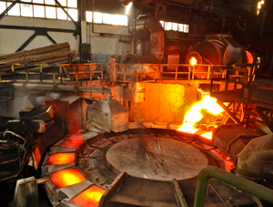
Copper scrap or blister copper is the input of the anode casting process. Before starting the anode casting process, copper refining is necessary to remove impurities, and oxides. To achieve this purification, the fire refining (oxidation) method is used. Removing metallic impurity constituents from copper is possible through the use of fire refining. According to the standard free energy of reaction, elements such as Fe, Sn, Al, Si, Zn, and Pb oxidize before copper during fire refining [4]. In anode casting, Thomas Furnace is used. Liquefied natural gas (LNG) is used as the energy source of Thomas Furnace. The furnace operating temperature is higher than the copper melting temperature which is 1083 °C. The reason for this high operating temperature is to prevent rapid cooling of copper and protect copper’s melt structure. In Thomas Furnace, several different processes take place. Firstly, 20-22 tons of raw material is sent into the furnace and this process takes about 45 minutes. The raw material sent into the furnace at one time is called charge. Subsequently, fire refining starts to get rid of impurities in copper and send them into the slag. During melting, impurities become slag which floats on the molten metal. The melting process lasts about 4 – 4.5 hours. The oxygen amount in copper reaches about 6000 ppm in that process. It prevents the formation of homogeneous and smooth anode copper. So, the oxygen content in liquid copper should be decreased. Approximately 1000 – 1500 ppm of the oxygen amount in copper is sufficient for an ideal anode copper. The oxygen decrease can be done by using a log of wood because it has high carbon content and high moisture. The hydrocarbons in the wood reduce the copper metal and the oxygen leaves as CO₂ gas. This process is called poling. After poling, the furnace heated for another 30 minutes. Then, molten copper is poured into crucibles. Molten copper in crucibles is transferred to molds which are made of copper. Then the mold cooling process starts. Water is supplied to the molds with a hose. After that, molds are immersed in the water. Due to its high melting point and insolubility in water, barium sulfate serves as a release material in the casting of copper anode plates. To avoid direct contact between the liquid copper and the solid copper mold, a layer of fine barium sulfate powder in water is applied to the mold surface. As a result, when the molten copper solidifies into an anode plate, it may be simply removed from its mold. At the end of the anode casting process, the slag is taken into the field. Then, it is given to the consumer.

Figure 3. Anode Casting [1]

3.2. Copper Electrolytic Refining

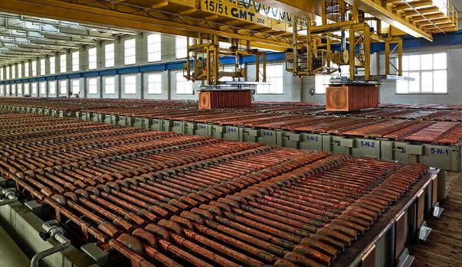
Anode copper plates are the input of the copper electrolytic refining process. After anode casting, anode copper plates go through electrolysis for further purification. At the beginning of the process, anode copper plates are immersed in electrolytes which contain CuSO₄ and H₂SO₄. Then, titanium sheets are repeatedly placed next to the anode copper plates. Titanium sheets are used as cathodes in this process. Applying a direct electrical current (nearly 16 kA) causes current to flow through the electrolyte between the cathode and anode copper plates. About 63-65 °C is ideal for dissolution. Cu is electrochemically dissolved from the anode into the electrolyte, producing Cu²⁺ ions and electrons. The electrons are conducted toward the cathode through an electrical current. Then, Cu²⁺ ions in the electrolyte migrate to the cathode by convection and diffusion [17]. Afterwards, the electrons and Cu²⁺ ions recombine to form pure metallic copper which is plated onto the titanium sheets. At about 19 – 20 hours, a copper layer starts to form on the titanium sheets. It takes approximately 7 days to get a cathode copper plate. The electrolyte is circulated through the cells. It should be fluent. If the same electrolyte is used all the time, ions accumulate and electrical conductivity decreases. Impurities in the electrolyte go to the treatment plant. Insoluble Pb anodes are being placed to remove impurities from the electrolyte by plating them on it. At the end of the process, high-purity ( > 99 %) cathode copper plates are produced.

Figure 4. Copper Electrolytic Plant [11]

3.3. Continuous Casting

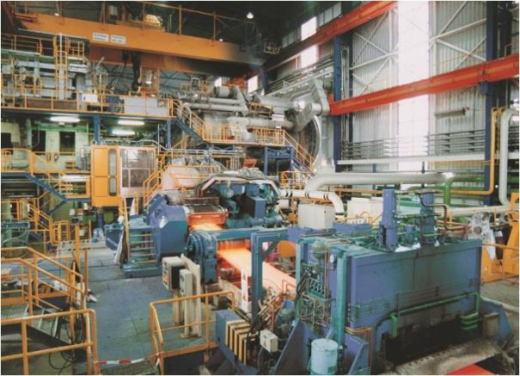
High-purity (> 99 %) cathode copper plates are the input of the continuous casting process. Briefly, the casting method in which molten metal is poured continuously from a tundish (molten metal reservoir) into a water-cooled mold and solidified metal is continuously withdrawn in the form of a plate is called continuous casting [16]. There are three main steps in the copper continuous casting process. These steps are the furnace part, casting part, and hot-rolling part. Shaft furnaces are used in this process. It consists of a vertical cylindrical chamber with burners located in the lower part of the furnace. It involves refractory materials. Their maintenance is done once a year. The process starts with a feeding furnace with 2.5 tons of cathode copper plates. The shaft furnace is heated up to nearly 1200 °C. At that temperature, cathode copper plates are melted. As mentioned above, the main idea behind heating up to higher temperatures than Cu melting temperature (1083 °C) is to prevent rapid cooling of copper and protect copper’s melt structure. Then, molten copper metal is transferred from the shaft furnace through closed channels to the casting machine. Molten copper solidifies in the HAZALETT casting machine and takes the shape of a busbar. If water comes into contact with the busbar, a very high-volume increase occurs due to evaporation. This increase may result in an explosion. For this reason, the busbar is not brought into direct contact with water. The busbar is cooled indirectly using coolant. Afterward, the hot copper busbar goes to rolling mills. There, the hot rolling process occurs using steel rolling mills. While rolling, the copper busbar undergoes diameter reduction and turns into a wire rod. The wire rod enters the surface cleaning and cooling line then a solution is sprayed to it then directed to the coiler. There, it is formed into coils. The production is completed by the packing operation. Continuous casting products belong to the class of electrolytic tough pitch ETP copper. After the packing operation, the products undergo several quality tests.

Figure 5. Continuous Casting Facility [5]

The first section of copper production involves anode casting, copper electrolytic refining, and continuous casting. The electrolytic copper is produced as a wire rod in the continuous casting plant. Now directed to another process to take its final shape.

3.4. Wire Drawing

Wire drawing is the second section of copper production. Wire drawing is a metalworking process used to reduce the cross-section of wire by drawing the wire through a single or series of drawing dies. This process consists of three main stages. These stages are single-wire drawing, multiple-wire drawing, and wire bunching.

3.4.1. Single Wire Drawing

The wire rod is the input of a single wire drawing. Single wire drawing involves four different steps. The first step is a single wire machine feeding with a wire rod which comes from a continuous casting process. With the help of the transmitter, the wire rods are transferred to the machine. Then, the drawing process starts. In the drawing part, the wire passes through the rolling mills. Gradual diameter reduction is done with a rolling process. It is possible to reduce from 8 mm diameter to 1 mm diameter. With rolling, copper metal undergoes cold working. Cold working is the phenomenon whereby a ductile metal becomes harder and stronger as it is plastically deformed below the recrystallization temperature. During plastic deformation dislocation density increases, the average distance between adjacent dislocations decreases, and dislocation mobility becomes more restricted; thus, the metal becomes harder, stronger, and more brittle [3]. To revert to the cold-worked properties, heat treatment can be applied to copper wire. Annealing is a heat treatment in which a material is exposed to a high temperature for a long period of time and then slowly cooled. It is important to say that annealing is an optional process, not a necessity. It depends on the customer’s requests. Annealing is typically used to relieve stresses, enhance softness, ductility, and toughness, and/or manufacture a specified microstructure. The annealing process is divided into three stages which are heating the material to the appropriate temperature (generally half of the melting temperature of the material), holding or "soaking" at that temperature, and finally cooling to room temperature. In the wire drawing process, the annealing mechanism is electrically induced and consists of contact bands. The wire passing through the nickel-plated contact bands heats up to about 600 C. Then it is cooled with emulsion and annealing done. After the annealing process, the final step, the wire winding step comes. Using a wire winder machine, single wire can be winded to the spool or the basket.

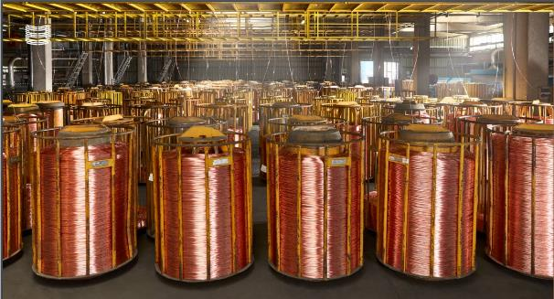
Figure 6. Copper Wire in Basket [7]

3.4.2. Multiple Wire Drawing

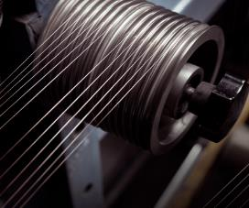
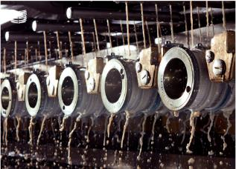
The input of the multiple wire drawing process is tin-plated, nickel-plated, alloyed or bare wire coming from the single wire. Multiple wire drawing involves four steps which are almost the same as single wire drawing process. The process starts with feeding multiple wire drawing machine by spools with using transmitter. Then, wire drawing comes. In the wire drawing section, the wire or wires pass through the drawing dies. The wires passing through the dies are gradually reduced in diameter. As mentioned above, single wire process allows to diameter be reduced to 1 mm. In multiple wire drawing, the wire can be made 0.05 mm. In addition, minimum 1 wire and maximum 32 wires can be drawn at the same time. At that point, the emulsion should be explained. An emulsion that contains water and oil is used during wire drawing. Emulsion plays a very critical role. There are several important purposes of using emulsion. Firstly, it reduces the friction force created by the wire as it passes through the drawing dies and allows the wire to be drawn more easily. Moreover, it reduces the particles that break off from the wire surface while the wire is being drawn and allows them to be transmitted to the filters. In other words, it helps to clean off the wire. The wire is drawn very fast (about 30 m/s), and heat is released in the system. Due to the fact that copper is a strong conductor, the material shows resistance as a result of the high voltage applied to the system because of the annealing process. Heat is released as a result of this resistance. The emulsion provides cooling of this heat. Afterward, in order to prevent corrosion of the wire, it is necessary to reduce its contact with oxygen. The oil in the emulsion forms a layer on the wire and reduces the contact of the wire with oxygen in the air. Since the speed of the wires coming out of annealing is not constant and equal, they come to the magazine before entering the winder. With the help of the piston in the magazine section, the speeds of the incoming wires are equalized. Wires with equal speed and tension are wound in the winder. Thus, it is ready for the customer.

Figure 7. Multiple Wire Drawing Machine (left side), Multiple Wire (right side) [7]

3.4.3. Wire Bunching

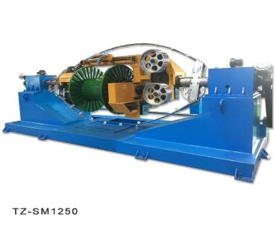
Bare, tin, or nickel-plated annealed wires processed by single and multi-wire drawing machines are used as inlet wires for bunching machines. These wires are bunched in Double Twist, Single Twist, Planet Strander, and Rigid Strander machines in cross-section areas ranging from 0.05 mm² to 360 mm². This process involves three steps. The process starts with feeding the bunching machine with copper wires. Then, twisting is done in the machine. The last part of the process is winding the bunched copper to the basket. At that point, the bunching machine must be detailed. Bunching machines are used to make wire products in the copper manufacturing industry. Bunching machines are designed to generate bunches with a constant and uniform twist, which is required for high-quality wire production. The machine is outfitted with a number of spools that keep the individual wires in place while a revolving twisting mechanism twists the wires together. That revolving twisting is done by a bow which is placed in the bunching machine. The most important parameters in wire bunching are the tightness of the twisting and the number of turns per unit length. These parameters determine the electrical and mechanical properties. On the other hand, bunching machines often contain a control system that monitors and manages the twisting process. The control system may be set to change the twisting speed and direction, as well as to stop the machine at a predetermined length. This enables the operator to manufacture bunches with uniform electrical and mechanical characteristics, independent of the wire size. The main motivation for bunching copper is to get more flexible and conductor wires with the same cross-sectional area. To reach this aim, the diameter of the single wires are drawn down and bunched together. The current will flow more easily through the wire due to the fact that the resistance of a wire is inversely proportional to the square of its diameter. So, the bunched wire becomes more conductor. Moreover, twisting wires together reduces the strain on each one. With the decrease of the strain, the bunched wire becomes more flexible. The microstructure of the bunched copper wire is affected by several parameters. Resistance, unit weight, bunched diameter, plating thickness if the copper wire is plated, and elongation are these parameters. In accordance with the customers' requests and standards, these parameters are adjusted.
Figure 8. Wire Bunching Machine [18]

The wire drawing process ends up with wire bending. Another process of copper wire is plating. As mentioned above, copper wire can be plated with nickel or tin.

3.5. Copper Wire Plating

Bare copper wire tends to undergo oxidation as time passes. This oxidation process results in the deterioration and a decline in its electrical performance, eventually leading to failure. So, bare copper wires are plated with tin and nickel, although they are sometimes delivered as bare copper wire according to customer requirements.

3.5.1. Nickel Plating

Nickel plating is the process of electrolytically depositing a layer of nickel onto a copper wire. Nickel is chosen for its sensational corrosion resistance which is primarily due to the formation of a thin layer of nickel oxide that acts as a barrier to prevent the occurrence of further corrosion. Moreover, to increase the wear resistance and hardness of the copper wire, nickel plating is used. The input of the nickel plating process is single wire. The process starts with setting the wire diameter and plating thickness in the computer. Then, the nickel plating machine is fed by single wire. First, the single wire is transferred to the degreasing bath inside the nickel plating machine. Here the surface of the wire is cleaned. Then, the wire passes to the etching bath. In the etching bath, the internal structure of the wire changes. It does not wait for etching, it is etched in motion. The surface cleaned and etched wire is transferred to the first magazine. Here the tension of the wire is reduced. Then it is sent to the nickel plating bath. The nickel plated wire is transferred to the second magazine for pressure adjustment. After the pressure adjustment, it is left in the plating bath again. The process ends with the wire being dried and wound on a winder.
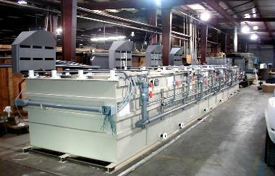

Figure 9. Nickel Plating Line [8]

3.5.2. Tin Plating

Tin plating is the process of electrolytically depositing a layer of tin onto a copper wire. Tin is a flexible, corrosion-resistant, and highly conductive element. That’s why it is used for the plating process to further enhance the corrosion protection, oxidation protection, conductivity, and solderability of the copper wire. The Tin plating process is similar to nickel plating. Degreasing bath, etching bath, plating bath, magazines, and winder are valid for both of these processes. However, there are some differences between these processes. For instance, tensioner spools are used for supplying tin plating machines. On the other hand, there is one plating bath and two magazines in the tin plating machine. Additionally, the content of degreasing - etching baths are different from each other.

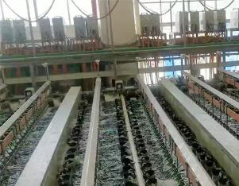
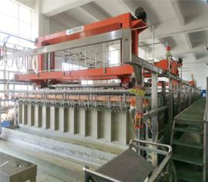
Figure 10. Tin Plating Line Pictures [13]

This is the way the manufacturing process of ETP copper, which can be in the form of bare, tin-plated, nickel-plated, and either wire-drawn or non-wire-drawn copper, is carried out. Besides ETP, there is another copper product called oxygen-free copper (OFC). The main difference between them is that ETP copper contains about 100-650 ppm O₂ whereas OFC contains a maximum of 5 ppm O₂. Moreover, OFC has a different production process.

3.6. OFC and Copper Alloys Facility

OFC is suited to produce enameled wires, superfine wires, and data transmission wires using multiwire drawing machines, as well as strips and curved wires using rotary extrusion machines. In OFC production, the upward casting method is used. Metallostatic pressure is used for this method. The input of the process is cathode copper. It is possible to produce 8 mm to 32 mm copper rods. The process starts with cathode feeding to the RAUTOMEAD machine. Individual cathodes are lifted from a pile near the machine and transferred to a tilting feed table above the machine's feed aperture using a suction pad. The feed table has a pneumatic clamping system that holds the trailing edge of the cathode and slowly lowers it into the molten bath. The surface of the molten metal in both the feed and casting chambers is protected from oxidation by a layer of fine graphite powder. Graphite is a good high-temperature engineering material that is exceptionally stable at increased temperatures and is not wetted by most liquid metals. It serves as a neutral to reducing the environment for many materials. So, this graphite flake powder interacts with oxides that may be present on the cathode's surface. Moreover, casting dies are small graphite tubular inserts. These are located in super-cooler die assemblies, which circulate cooling water. Each assembly is clamped in a frame above the crucible, and the lower end of the casting die is plunged to a predetermined depth in the molten metal. The frame is designed to move up and down in order to keep the immersion depth constant relative to the metal surface. Additionally, a specially designed internal bed of small graphite ring shapes is integrated into the lower section of the crucible. This arrangement ensures that when the liquid copper flows from the melting chamber of the crucible to the casting die chamber, it must pass through this portion of high-surface-area graphite. This process effectively eliminates any oxygen present in the molten copper. Then, the OFC product goes through the wire drawing process. The drawing of copper wires is achieved through the utilization of double pinch roll transporter mechanisms, which are situated above the super cooler die assemblies and operated pneumatically. The pneumatic pressure can be customized for each pair of rolls independently, allowing for individual drawing of copper wires in different strands. Finally, the OFC wires are coiled to the basket.

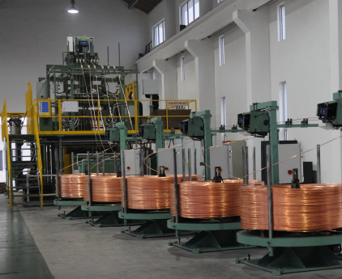

Figure 11. Upward Casting and Coiling [15]

After upward casting, that 8 mm or 32 mm OFC product may undergo other processes according to customer requirements. Continuous Extrusion Forming (CONFORM) is the second process.

3.6.1. CONFORM

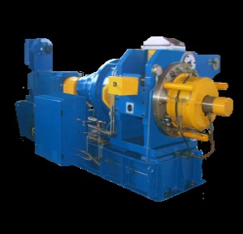
In the beginning, the CONFORM process is based on rapid and intense plastic deformation with the help of friction forces. The aim is diameter reduction and grain refinement. The input of the CONFORM process is the upward casted cold-state OFC rod or copper alloy bar. The process starts with inserting the OFC rod or copper alloy bar in the die cavity as a raw material to induce rapid and severe plastic deformation after friction drive was provided to the rod billet by continuous extrusion utilizing a wheel groove. As a result, the billet's temperature increases to approximately 800 °C to complete the continuous extrusion thermal deformation. Then, hot rolling is done near the die's exit, and the heat that remains after continuous extrusion is used as thermal energy for the hot rolling. In the CONFORM machine, roller bearings with numerous seals to retain oil and prevent foreign material entry are used. A separate lubrication system that is pressurized, filtered, and cooled guarantees that the bearings are appropriately lubricated and that the right operating temperatures are maintained. The CONFORM process has several advantages compared to traditional extrusion methods. Firstly, the heating procedure is avoided. Deformation heat and friction heat are utilized to achieve the material's thermal deformation temperature and complete the extrusion and rolling processes. Then, the frictional resistance for energy dissipation is converted into the deformation driving force, maximizing energy usage. Both continuous extrusion and rolling totally achieve thermal deformation of the billet, which results in dynamic recrystallization [21]. Moreover, the CONFORM process has a positive effect on grain refining. The high plastic deformation of the OFC rod or copper alloy bar during CONFORM results in the production of a high number of dislocations and substructures as well as the refining of grain size. These dense dislocation structures and fine grain would reduce the activation energy of recrystallization, causing the nucleation rate of recrystallization to rise [20]. At the end of the process, the product can be delivered to the customer or transferred for further processing.
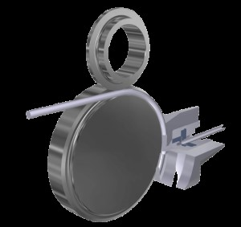
Figure 12. CONFORM schematic representation (left side), CONFORM machine (right side) [2]

Shaving (draw-peeling) is the next process. If necessary, the copper rod can go through this process after CONFORM for further diameter reduction and increasing smoothness of the surface.

3.6.2. Shaving

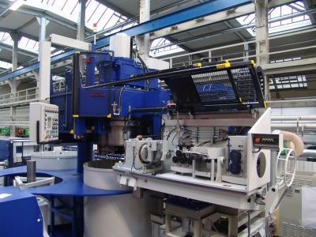
Shaving constitutes a cutting procedure wherein a shaving die serves as the cutting tool. This die is a static instrument equipped with a circular blade. While its overall geometry resembles that of a conventional drawing die, a notable distinction lies in the presence of a cutting edge. The requisite force for advancing the material through the straightener, the lean die, and the shaving die is supplied by the drawing capstan. During the shaving process, the chips generated are subjected to cooling through a coolant, a measure aimed at enhancing the longevity of the tool. Shaving is employed under specific circumstances that demand pristine surface quality, uniform material structure, and material purity. Moreover, it increases the workability of the material. It is capable of rectifying various types of defects. In the realm of copper processing, these defects may arise from the rolling process or the production of the raw material, negatively affecting the material's smoothness. To effectively eliminate these defects, subjecting the material to the shaving process becomes imperative. Moreover, depending on the tensile strength of the wire, integration of the shaving operation may be necessary. For example, with exceedingly tough materials, multiple draw-peeling operations might be essential. The increased tensile strength contributes to more efficient chip breaking, a feature achieved in the second stage.

Figure 13. Wire Shaving Machine [9]

During the internship, the ribbon production line constituted the majority of the R&D work. It was a process in which I took an active role throughout my internship. At that point, it is crucial to explain the ribbon machine in detail.

3.7. Ribbon Production Line

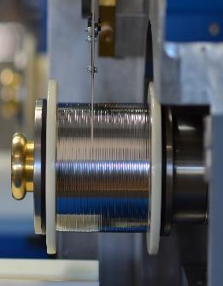
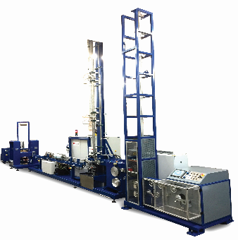
The ribbon production line involves a ribbon machine. The machine consists of several sections. These sections are the transmitter section, cleaning units, rolling section, measuring device (width-thickness), capstans and magazines, plasma section, solder plating section, and winder. The transmitter section is the equipment that supports the continuous progression of the input wire produced for the final product along the line and is used to adjust the wire tension in this progression. A pneumatic piston system is used to adjust the wire tension. The cleaning unit 1 section is used to remove the basic surface defects that may occur on the input wire due to waiting, weather conditions, and production. The working system is based on spraying water with constant pressure on the surface of the wire. At the exit of the cleaning units, air-pressurized blades are used to dry the wire surface. The rolling section is used for the production of ribbon wire used in photovoltaic cells. The unit consists of three main rolling mill systems, three separate motors to drive these systems, 3 pneumatic pistons positioned at the exit of each mill, a magazine mechanism, a shaft cooling system, a wire surface, and a rolling surface cooling system. The rolling unit can produce using one or three rolls depending on the input wire diameter and final product dimensions. The rolling process is a cold deformation process realized by adjusting the height of the rolls appropriately after the input wire leaves the first cleaning unit. The rolling process starts with the wire passing through the first roll and continues through the magazine to the other rolls. During this time, emulsion and shaft water cooling systems are used to prevent heating of the wire surface and rolling mill surfaces. The second cleaning unit section is used for cleaning the emulsion residues that may remain on the produced wire. The inlet capstan and magazine section are equipment designed for the coordinated operation of the system. This equipment increases and decreases the distance with the pneumatic piston on it when necessary. In this way, it prevents inconvenient situations such as rupture that may occur in the line length. In addition, thanks to the bidirectional pneumatic piston, the wire tension can be adjusted as desired by changing the pressure values. The measuring device gives feedback to the rolling mill by measuring the thickness and width of the wires and changes the compression force values applied in the rolling mills, ensuring that the product produced is as close as possible to the desired dimensions. The basic principle of heat treatment in the plasma section is to relieve the stresses of the wire with high yield strength formed in the cold deformation process. In addition, the plasma plays a role in cleaning the wire surface and activating the coating for adhesion. The plasma system consists of two vacuum pumps to create an oxygen-free environment and a recirculation pump to circulate the nitrogen supplied to the line. There are electrode and cooling sections on the plasma. The electrode section is cooled by indirect oil cooling. An indirect water cooling system is used for oil cooling. The wire coming out of the plasma after annealing is cooled directly with nitrogen. During annealing, the wire reaches a temperature of approximately 550-650°C and at the end of cooling, the temperature drops to approximately 200-220°C. The solder plating section is the hot-dip plating of molten solder operating between approximately 200-300°C. The wire coming from the plasma section is immersed in the solder pool without contact with the air. The plated wire goes up vertically and proceeds to the cooling section. The molten solder-coated wire moves in the water cooling tower without any contact point. Cooling is realized by means of nozzles spraying pressurized water inside the water tower. In the outlet capstan and winder section, the capstan offers the possibility of changing the rollers to adjust the speed imbalances along the line. Winding tension is adjusted with the pneumatic piston in the winder. At the end of the process, the product coiled to the spool. It is sent to the quality control and R&D department for necessary tests and measurements.

Figure 14. Ribbon Line (left side), Ribbon Spool (right side) [14]

Samples are taken from the products that come out of the ribbon machine wrapped on spools. One sample is taken to the quality control department. Here they are subjected to a tensile test to find the elongation, yield strength, and tensile strength values. Another sample which came from the same spool is then taken to the R&D department. In the R&D department, coating thickness is measured. Additionally, microstructure observation is done using optical microscope. To do this observation, sample preparation is needed.

3.8. Sample Preparation

The sample preparation steps are mounting, grinding, polishing, and etching.

3.8.1. Mounting

Mounting protects fragile or coated items during preparation and provides flawless edge retention. Mounting is used to protect layers and to make the handling of tiny, sharp, or irregularly shaped specimens safer and more convenient. There are two types of mounting which are hot mounting and cold mounting. In the metallography laboratory, cold mounting process was observed. There are three types of cold mounting processes which are epoxy, polyester, and acrylic cold mounting. In the metallography lab, the acrylic cold mounting process was done. Since acrylic resins are simple to use and have fast cure periods, very little shrinkage, and good mounting qualities. They are ideal for the laboratory. Acrylic cold mounting starts with the neatly cut, dry, and clean specimen placed vertically in the mounting cup. Afterward, cold bakelite powder and acrylic resin liquid are mixed in certain proportions. This resin mixture is poured over the specimen and the filled mounting cups are left to harden. After waiting for a certain period, the sample is ready for further processing. The most critical points in the cold mounting process are mixing and curing times. These parameters directly affect the quality of the prepared sample.

3.8.2. Grinding

After the mounting process, the sample encased in bakelite is subjected to grinding. The grinding process is based on the employment of abrasive particles with gradually smaller grain sizes to remove material from the surface until the desired result is reached. Abrasive paper which is covered by silicon carbide (SiC) grit is used for grinding. Grit numbers are sorted as 80, 120, 220, 320, 400, 600, 800, etc. The higher grit number corresponds to a smaller average particle diameter. The initial grit number is determined by the surface roughness and depth of sectioning damage. In the metallography laboratory, the grinding is done using an electronic device. Generally, grit number 600 is chosen as the initial. Then, depending on the surface characteristics of the sample and the desired surface smoothness, other grit numbers are taken.

3.8.3. Polishing

After the grinding process, the sample undergoes another process. Polishing is the final step of the sample preparation. Polishing is applied to fine particles to produce a flat and scratch-free surface with high reflectivity. The polishing process is done in the same electronic device as grinding. A suitable solution for the sample is chosen at the beginning. Then, the device starts the process. After a certain period, polishing is done. The polished sample is washed with pure water first. Then it is cleaned again with alcohol and left to dry. At the end of the process, the sample can be examined under an optical microscope. If there is a need for an examination where the microstructure is further revealed, the sample is subjected to another process called etching.

3.8.4. Etching

The etching process involves using chemicals to selectively dissolve a material's surface to reveal microstructural features. Etching is essentially a type of controlled corrosion. With the etching process, much clearer images are obtained under the microscope. Grain boundaries and grain structures can be clearly observed. In the chemistry laboratory, the etching process is done using an etching recipe. A solution containing 20 mL NH₄OH, 1 g (NH₄)₂S₂O₈ (ammonium persulfate), and 60 mL distilled water was prepared based on the ASTM No: 43 etching recipe [11]. The sample was etched for about 50 seconds. Afterward, it was first washed with distilled water and then cleaned with alcohol. After the etching process ends, the sample is examined in the optical microscope.
The whole copper wire production process involves anode casting, electrolysis, casting, and wire drawing. Additionally, another different process, OFC production is carried out. Then, as mentioned above, the ribbon machine gives solder plated copper wires. The samples that come from the ribbon machine are examined in the R&D Metallography Laboratory. Coating thickness measurements are done here. At that time, it is crucial to explain how these measurements are done there. The XDV-μ spectrometers are used. XDV-μ spectrometers are based on the X-ray fluorescence (XRF) characterization method.

3.9. XDV-μ SPECTROMETER

The XDV-µ X-RAY instrument is an energy-dispersive X-ray measurement device with a specific focus on non-destructive analyses and the measurement of coating thicknesses on exceptionally small components and intricate coating systems. To optimize excitation conditions for each measurement, this instrument is equipped with electrically adjustable primary filters. The utilization of a silicon drift detector ensures precise measurements and excellent detection sensitivity. Additionally, the incorporation of polycapillary X-ray optics allows for highly precise measurements with a remarkably small measurement spot, coupled with a significantly high excitation intensity. As mentioned above, this spectrometer is based on XRF. In more detail, XRF analyzers ascertain the chemical composition of a sample by quantifying the fluorescent, or secondary, X-rays emitted from the sample upon exposure to a primary X-ray source. Every element contained within the sample generates a distinct set of characteristic fluorescent X-rays that are specific to that element. This is the reason why XRF spectroscopy is highly effective for both qualitative and quantitative assessments of material composition.


Figure 15. XDV-µ X-RAY device [19]
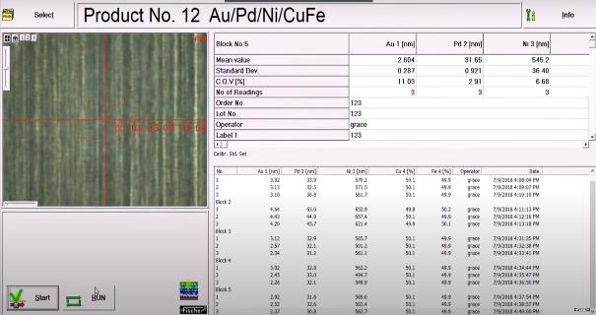
The coating thicknesses of the samples are done using the device in Figure 15. The measurement process involves several steps. This device is conceived as a bench-top instrument and comes equipped with several key features. It includes a high-precision, programmable XY-stage, and an electrically driven Z-axis. When the protective hood is opened, the sample stage automatically positions itself into the loading position. A laser pointer serves as a tool for positioning and facilitates the rapid alignment of the sample earmarked for measurement. Additionally, a high-resolution color video camera aids in the accurate identification of the measurement spot. All aspects of operation, measurement evaluation, and the clear display of measurement data are carried out on a PC through the utilization of specialized software.

Figure 16. An image from the device.

4. CONCLUSION

During my internship, I had the valuable opportunity to apply the theoretical knowledge I had acquired in school to professional working life. I observed various departments, including anode casting, electrolytic refining, continuous casting, upward casting, tin and nickel plating, wire drawing processes, metallography, mechanical testing, sample preparation, sample examination using the XDV-µ device, and production lines. Over the course of this 20 working days internship, I gained profound insights into the intricacies of production and R&D. It was a real demonstration of the substantial effort required to attain desired outcomes. Witnessing the impact of altering parameters on ZnPb coated copper wire was particularly enlightening. My time in the R&D department has significantly influenced my future career aspirations.
Throughout this internship, I had the opportunity to observe the entire copper wire production process, from transforming scrap copper into impressive-looking wire rods. This experience broadened my perspective on the industry and taught me to approach it from various angles. I believe that I made considerable professional growth during this internship, particularly in terms of persistence and resilience.

5. REFERENCES

[1] Anode Casting | Sarkuysan Elektrolitik Bakir Sanayi ve Ticaret A.S. | Energy & Utilities | Energy & Utilities. (n.d.). Retrieved from https://energy-utilities.com/anode-casting-prod1240799.html
[3] Callister, W. D., & Rethwisch, D. G. (2010). Materials Science and Engineering: An Introduction.
[4] Committee, A. I. H. (2008). ASM handbook: Casting. Volume 15.
[5] Copper anode — Hazelett Strip-Casting Corporation. (n.d.). Retrieved from https://www.hazelett.com/copper-anode
[8] KCH Services Inc. (n.d.). Electroless Nickel Plating | KCH Services Inc. Retrieved from https://kchservices.com/company/applications/surface-metal-finishing/electroless-nickel-plating
[12] Materials, A. S. F. T. A. (2007). ASTM E 407-07: Standard Practice for Microetching Metals and Alloys.
[16] Sarkar, J. (2014). Sputtering target manufacturing. In Elsevier eBooks (pp. 197–289). https://doi.org/10.1016/b978-0-8155-1593-7.00004-7
[17] Schlesinger, M. E., Sole, K. C., & Davenport, W. G. (2011). Extractive Metallurgy of Copper. Elsevier.
[18] Wire Bunching. (n.d.). Retrieved from https://www.taizhengmachine.com/double-twist-copper-wire-bunching-machine-taizheng.html
[19] X-Ray XDV | Precise XRF Coating Thickness Measurement | small measurement. (n.d.). Retrieved from https://www.helmut-fischer.com/products/fischerscope-x-ray-xdv-mue
[20] Yuan, Y., Zhou, L., Xiao, Z., Zhao, Z., & Yang, Z. (2017). Microstructure evolution and properties of Cu-Cr alloy during continuous extrusion process. Journal of Alloys and Compounds, 703, 454–460. https://doi.org/10.1016/j.jallcom.2017.01.355
[21] Yun, X., You, W., Zhao, Y., Li, B., & Fan, Z. (2013). Continuous extrusion and rolling forming velocity of copper strip. Transactions of Nonferrous Metals Society of China, 23(4), 1108–1113. https://doi.org/10.1016/s1003-6326(13)62572-8

